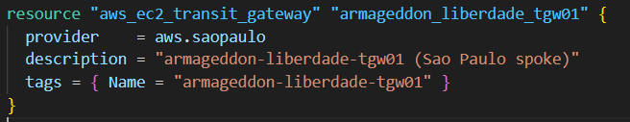
What it creates: a Transit Gateway (TGW) in the São Paulo region (because of provider = aws.saopaulo).
Why it exists: a TGW is a “routing hub” that can connect multiple networks (VPCs, VPNs, and peering attachments).
Result: you now have a São Paulo TGW that can attach to the São Paulo VPC and peer to Tokyo’s TGW.
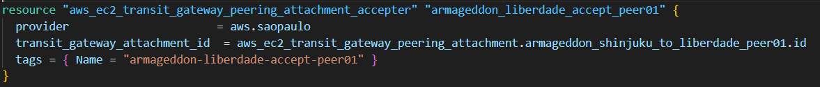
What it does: accepts a Transit Gateway Peering Attachment that was created on the Tokyo side (the requester).
Key detail: TGW peering across regions is a two-step handshake:
- Tokyo creates the peering attachment request (aws_ec2_transit_gateway_peering_attachment ...)
- São Paulo accepts it (aws_ec2_transit_gateway_peering_attachment_accepter ...)
Result: the cross-region TGW peering is now active from São Paulo’s perspective.

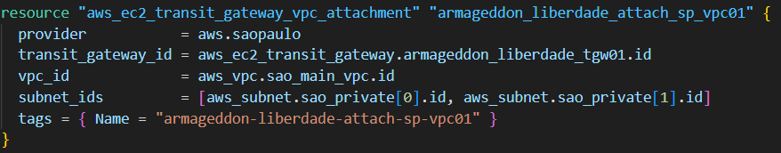
What it does: connects the São Paulo VPC (aws_vpc.sao_main_vpc) to the São Paulo TGW.
Why subnets matter: the subnet_ids are the “attachment subnets” where AWS places TGW ENIs. Best practice is:
- use private subnets
- use at least 2 AZs (you’re doing that with [0] and [1])
Result: resources in the São Paulo VPC can route traffic to/from the TGW.

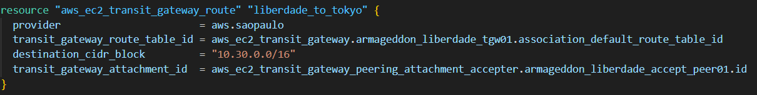
What it does: tells the São Paulo TGW:
“To reach Tokyo’s network 10.30.0.0/16, send traffic over the peering attachment.”
Where it adds the route: the TGW’s default association route table (association_default_route_table_id). That means:
- any attachment that’s associated with that default TGW route table will learn/use this route.
Result: TGW-level routing now knows how to reach Tokyo’s CIDR via the TGW peering.

